**Final Project**



Max Sazhaev, ManpreetMatharu, Kyle Puno, Igor Brovchenko

**Table of Contents:**

Page 1: Title and logo

Page 2: Table of Contents

Page 3: Version history, Detailed Game Description, Controls, and Interface Sketch

Page 4: Screen Descriptions (Start State and Gameplay State)

Page 5: Player Interface

Page 6: Screen Descriptions (Game-End State), Characters/Vehicles, Enemies, Scoring, and Sound Index

Page 9: Game Details

Page 10:Art / Multimedia Index (bullet image, grass image, tank mesh, bomb mesh, wrench mesh)

Page 13: All Assets Used

**Version History:**

Version 1 – January 3rd 2018

1. Added first person character, 3 levels with unrelated end conditions, and 2 death walls, start scene, end scene, death scene.
2. Added zombies that chase.
3. Added score, life and time to UI
4. Added gas cans you can collect and simple game music

Version 2 – January 10th 2018

1. Added options, instructions, player health decreasing, human conversion with human models
2. Humans repel, changed end condition to number of converts
3. Added animations, fixed humans and zombies falling over, added nav meshes to levels
4. Changed canvas to include humans left.
5. Added player model and animations for everyone.
6. Made death scene respawn at current level.
7. Control converted zombies
8. Show final score in the end, added sound effects for conversion and death
9. Changed game music
10. Added difficulty that unlocks.

**Detailed Game Description:**

Level 1 – Get to the end of the training maze while picking up gas cans.

Level 2 - Get across the bridge of lava and convert all the humans to zombies.

Level 3 – Convert people in the small town in the middle of nowhere.

**Controls:**

WASD – Forward, left, back, right.

Space – Jump.

Shift – Sprint.

Left mouse button – Select zombie.

Right mouse button – Command zombie

**Multiplayer:**

LAN Coop multiplayer for 2 players.

**Interface Sketch:**

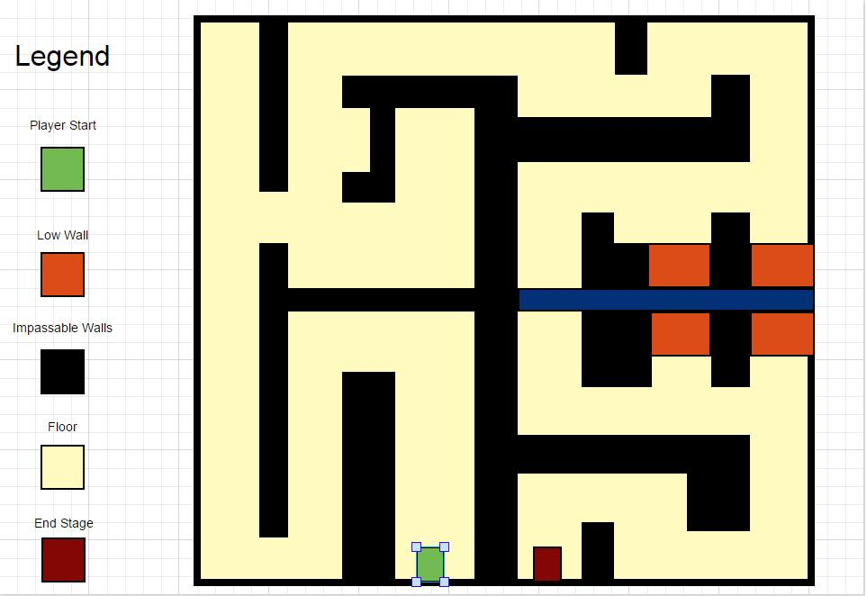

**Player Interface:**

* Player’s Score in the top left corner
* Play Time in the top middle of the screen
* Player’s Life in upper right corner
* Counter of the humans remaining on the level in lover left corner

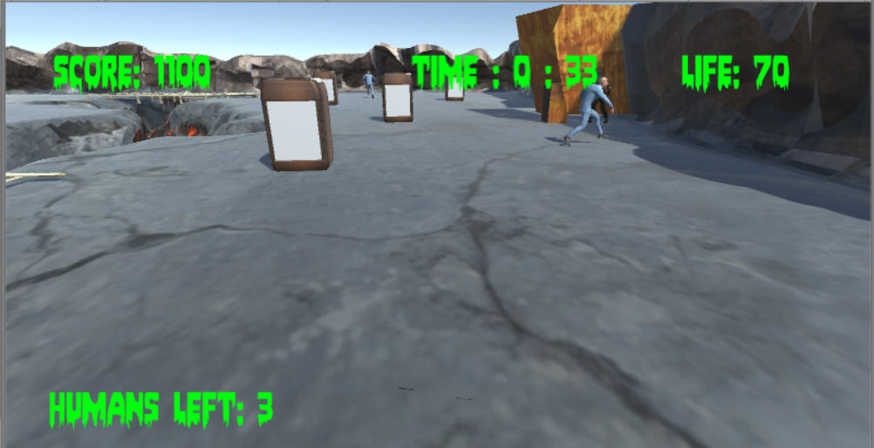

**Screen Descriptions:**

Start State:

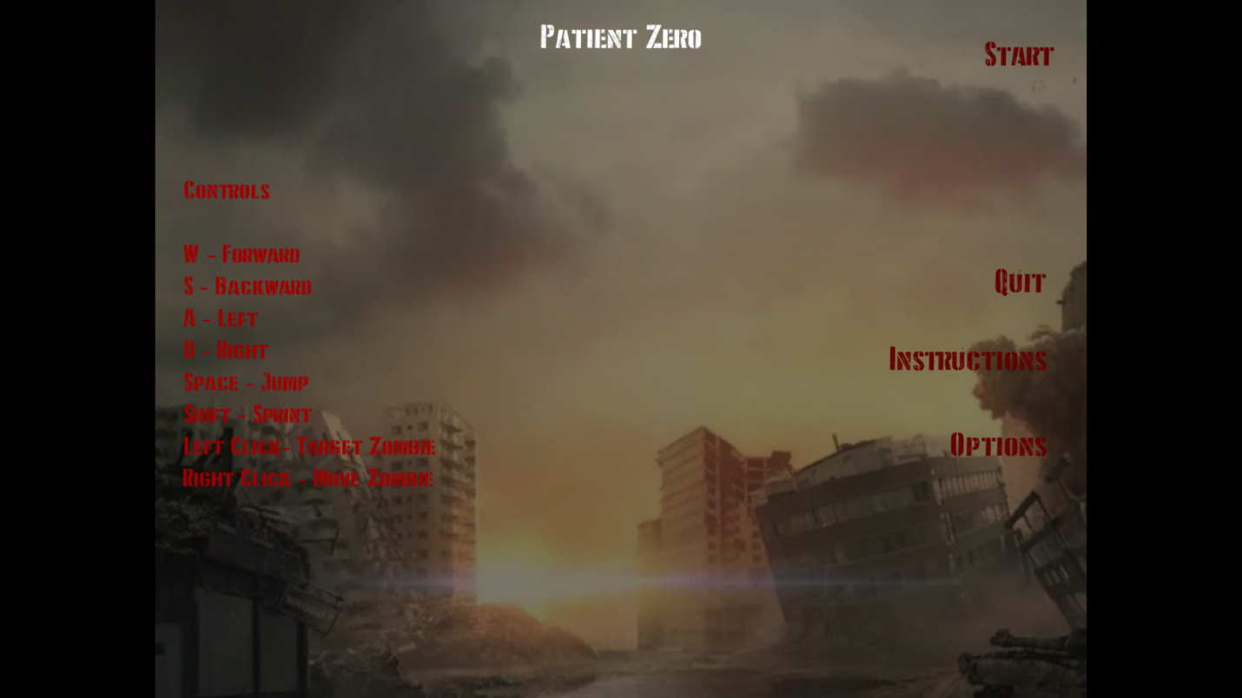

Death State:

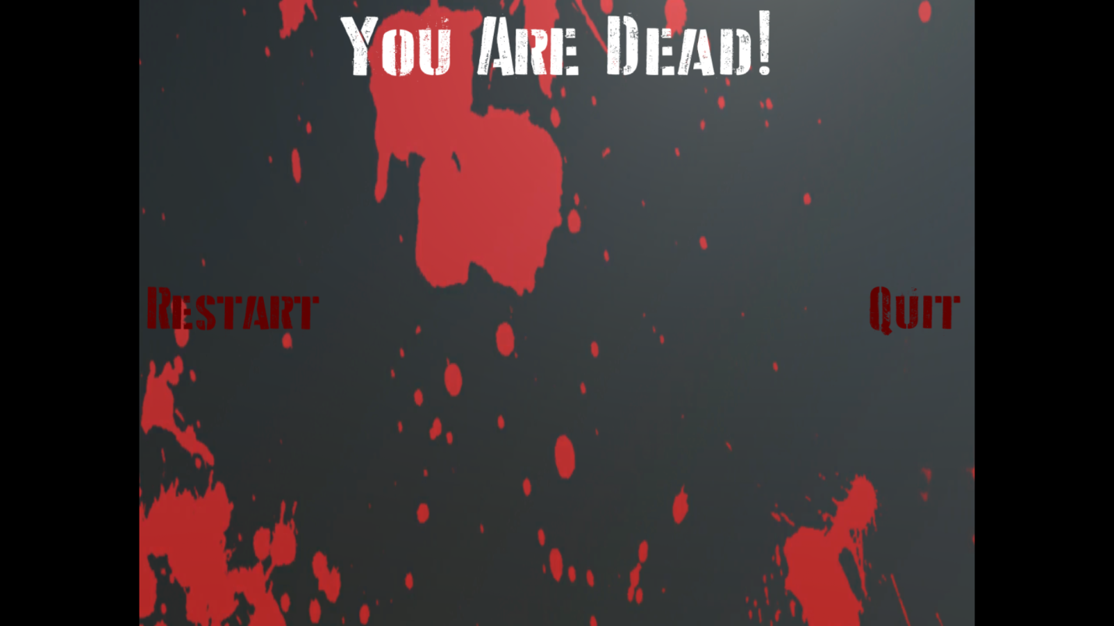

End State:

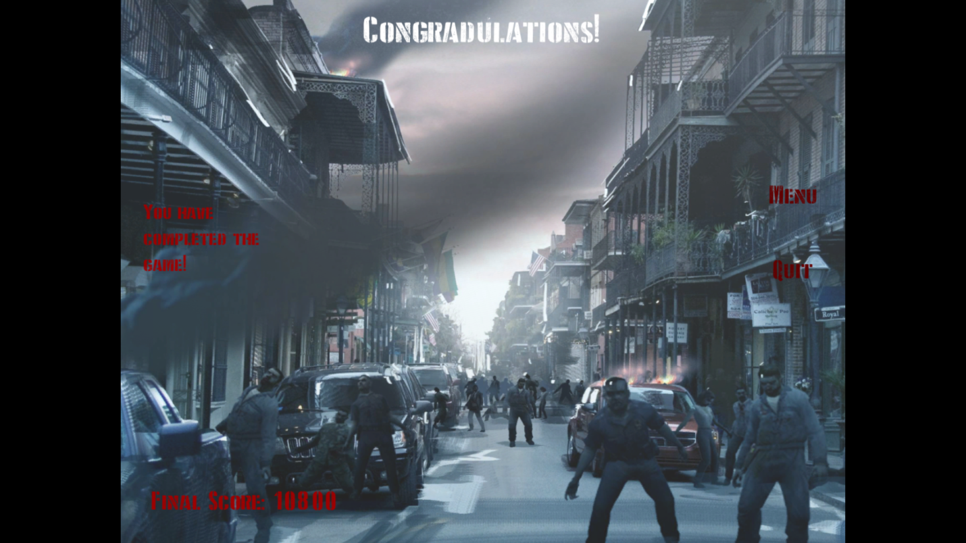

Level 1:

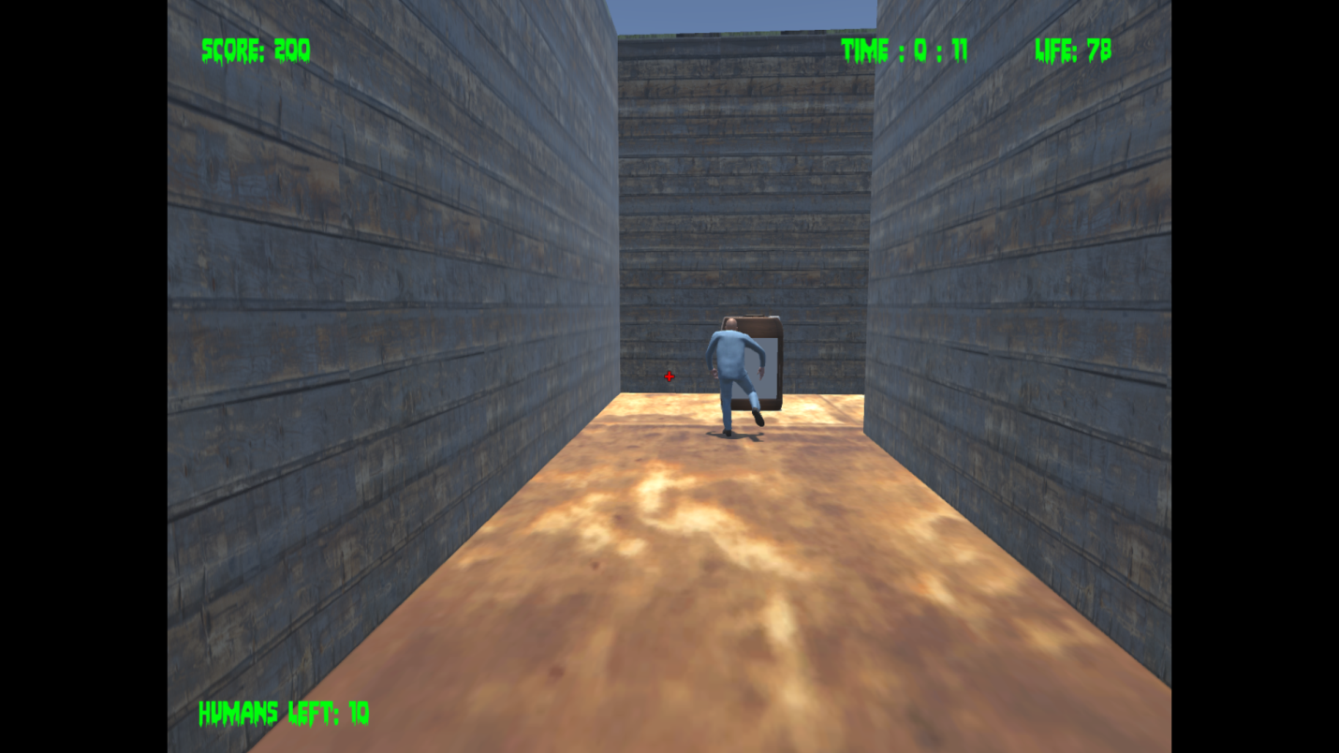

Level 2:

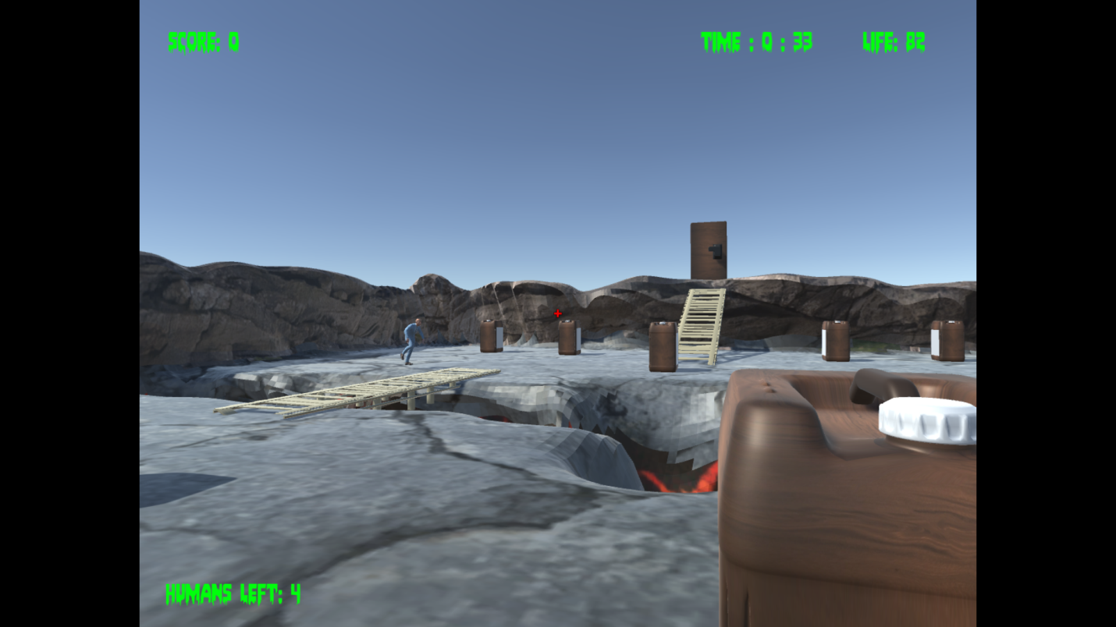

Level 3:

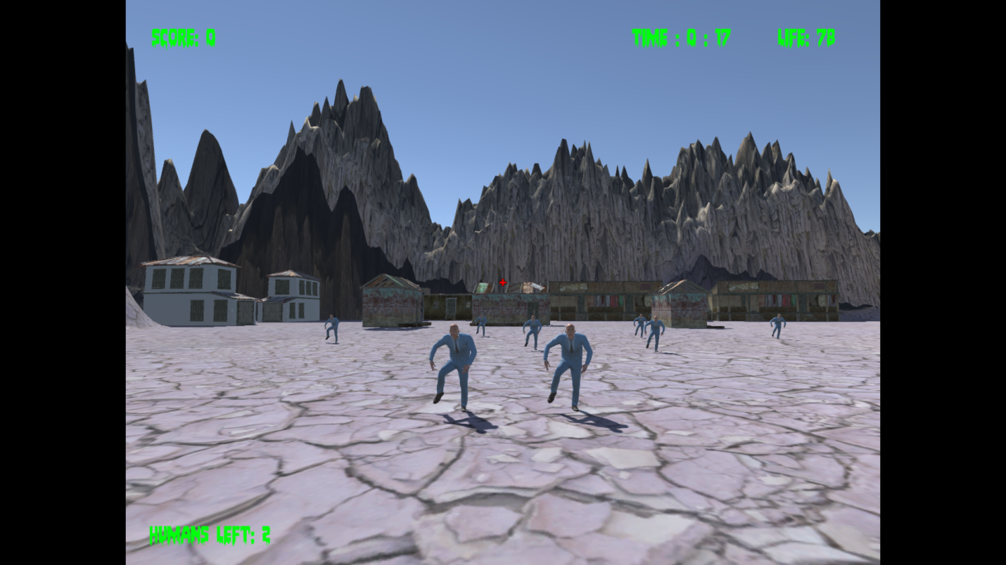

**Game World:**

It was just a few weeks since the break out of zombie virus. Humans are running in panic without even trying to fight. Recently dominant species is hiding away from big cities, such as small towns and insane asylums. In game you will visit different sights to witness and speed up the end of human race.

**Levels:**

**Insane Asylum -** This is inside an insane asylum. The hallways looks very gloomy and the structure is maze-like. Perfect for hunting humans. You have to jump over a pit which could kill the zombie

## Town - Just a small town outside the city, it contains some rocks, houses, and a well, and some cars.

## Bridge - Some areas in the city have been destroyed, ground has collapsed and the humans needed a bridge to cross it, but so do you.

**Characters / Vehicles:**

Player – moves forward, back, left, and right. Also jumps and sprints. Controls zombies.

**Enemies:**

Humans, running away from danger.

**Scoring:**

Easy difficulty: 100 points per collected gas can, 1000 for converting human

Medium difficulty: 200 points per collected gas can, 2000 for converting human

Hard difficulty: 400 points per collected gas can, 4000 for converting human

**Sound Index:**

Footstep01 – Walking Sound

Jump – jump up sound

Land – Landing sound

Zombie conversion - zombie conversion

Zombie death – zombie death sound in death scene

Funeral Music – Death Scene

Life is strange main menu music – Menu Scene

In the House, In a Heartbeat - John Murphy – First level

Push it to the limit – Second Level

The Grand Cathedral from Serious Sam the 2nd Encounter – Third level

Kavinsky – Nightcall – Finish Menu

**Art / Multimedia Index:**

Rust Texture used in level 1:

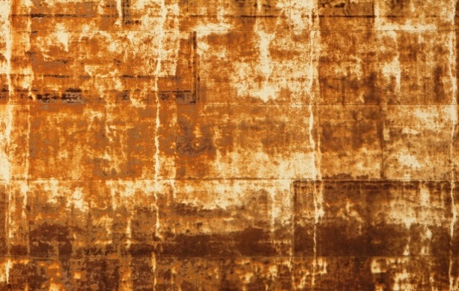

Water Texture used in level 1:



Wood Texture used in level 1:



Main menu background used in menu scene:

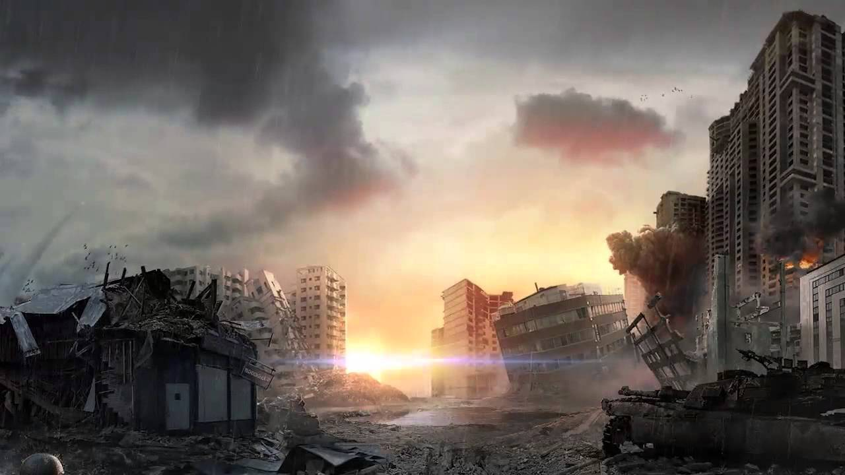

Win menu background used in win scene:

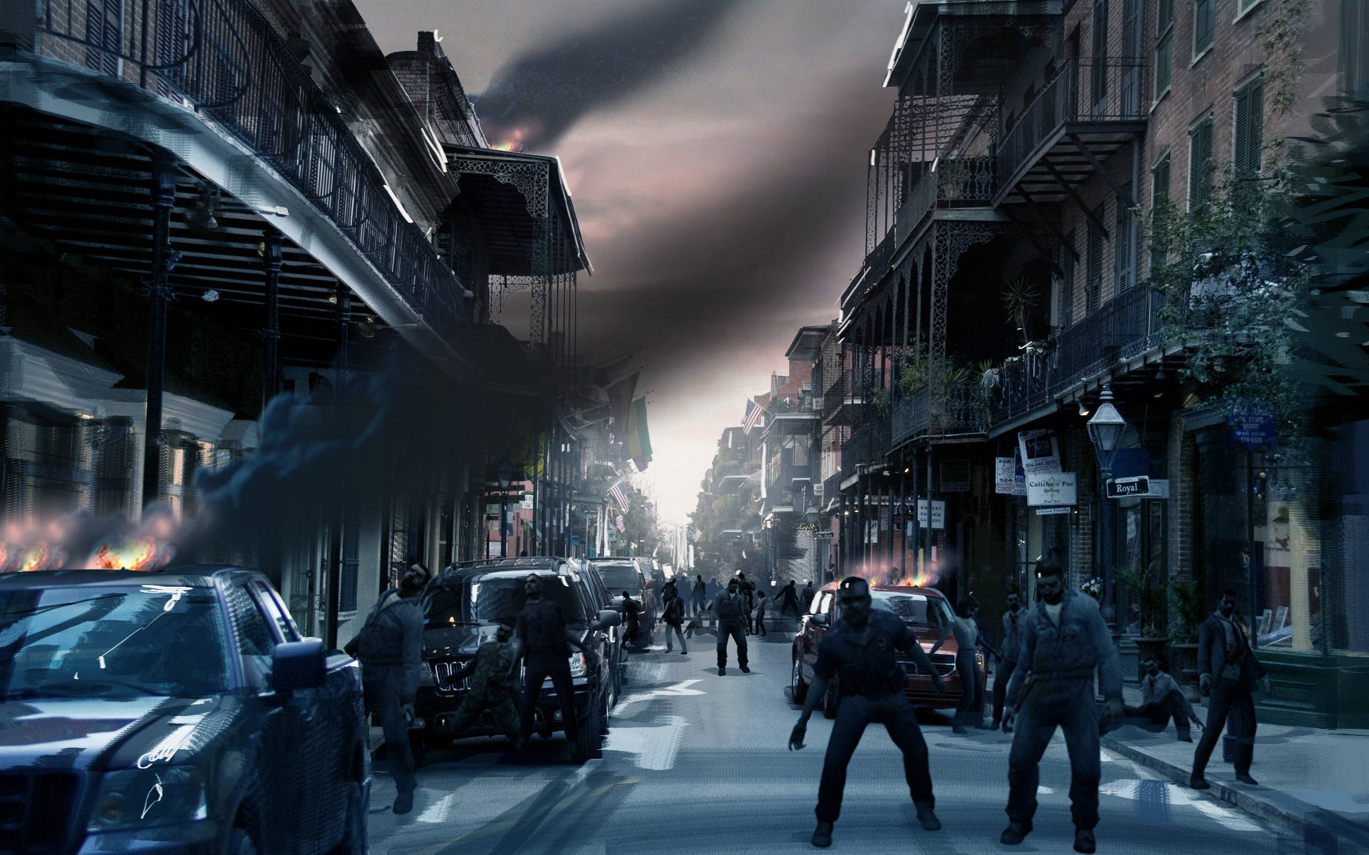

Death scene background:

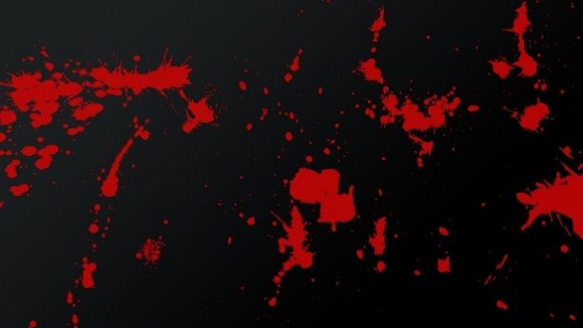

Door:

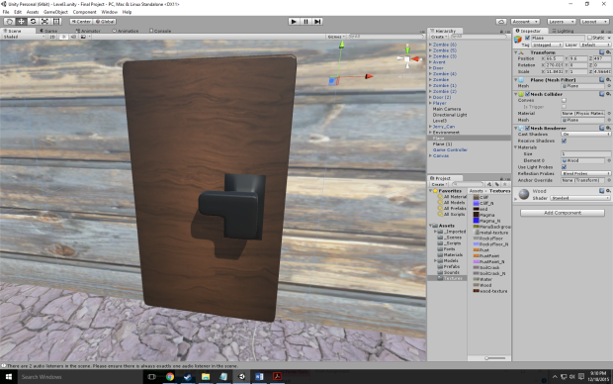

Gas Can:

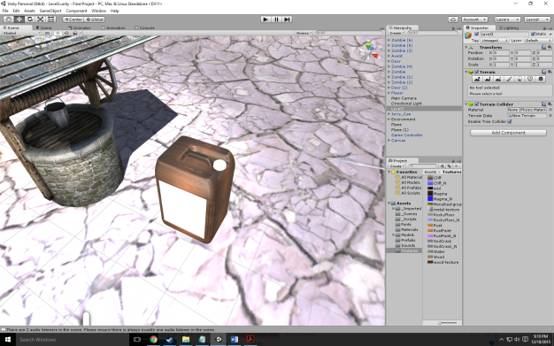

DDay font:

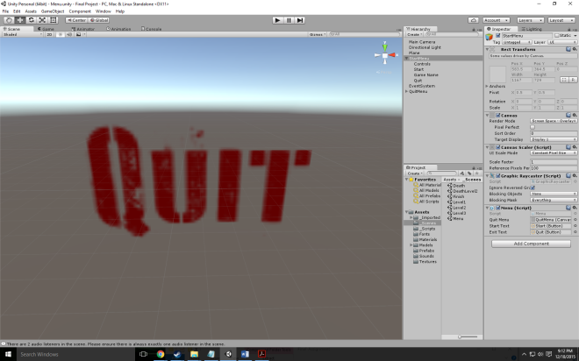

Bloodlust font:

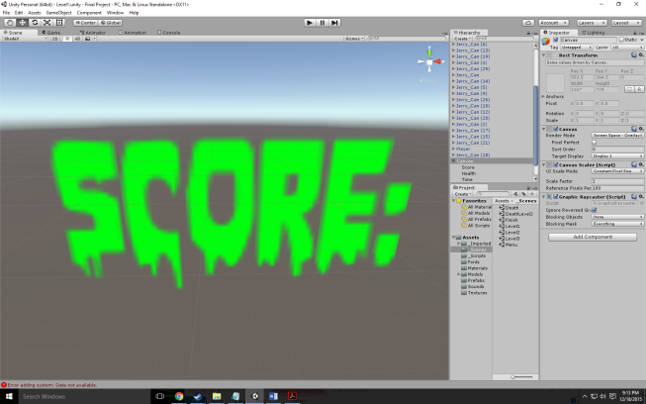

**All Assets Used:**

Wood Floors - <http://www.textures.com/download/woodplankspainted0191/66695>

Rusted Walls - <http://www.textures.com/download/rustpaint0170/31195>

Water Pit - <http://www.textures.com/download/waterplain0035/103458>

Door - <http://tf3dm.com/3d-model/modern-door-60753.html>

Menu Background - <http://wallpapercave.com/wp/9uIjAfm.jpg>

Death Background - <http://orig12.deviantart.net/db12/f/2012/038/5/0/blood_splatter_background_by_pudgey77-d4ozy89.jpg>

Zombie sounds (conversion and death): <https://www.youtube.com/watch?v=qCFdpOMiCzs&t=51s>

Win background: [https://hdwallsource.com/img/2016/6/zombie-wallpaper-background-52288-53997-hd- wallpapers.jpg](https://hdwallsource.com/img/2016/6/zombie-wallpaper-background-52288-53997-hd-%20wallpapers.jpg)

Menu background: <https://i.ytimg.com/vi/_60hYyvt9Cs/maxresdefault.jpg>

End song: <https://www.youtube.com/watch?v=MV_3Dpw-BRY>

Level 1 Music: https://www.youtube.com/watch?v=ST2H8FWDvEA

Level 2 Music - <https://www.youtube.com/watch?v=9D-QD_HIfjA>

Level 3 Music - <https://www.youtube.com/watch?v=0IVRoqDWwIk>

Menu Music - <https://www.youtube.com/watch?v=S3W0M8SVmk0>

Victory Music - <https://www.youtube.com/watch?v=MV_3Dpw-BRY>

Death Music - <https://www.youtube.com/watch?v=SQ1nGH4VBEQ>

Item pickup: <https://www.youtube.com/watch?v=J-21BggTCbA>

Gas Can - <http://tf3dm.com/download-page.php?url=cooking-oil-jerry-can-88575>

Bloodlust font - <http://www.1001freefonts.com/bloodlust.font>

D-day font - <http://www.dafont.com/d-day-stencil.font>

Human model: <https://www.assetstore.unity3d.com/en/#!/content/51662>